PROJECT ON

TRAFFIC VIOLATION

Savla, Neel Girish

CALSTATELA, CIS 5270 (PROF. SHILPA BALAN)

1. **Data Set URL’s :**

<https://data.montgomerycountymd.gov/Public-Safety/Traffic-Violations/4mse-ku6q>

The data set contain 35 interesting Columns and about 1.26 Million rows for different variations of analysis and visualization, which can be further used for public safety and improvement on security.

The Columns and their descriptions are as follows:

| Column Name | Description | Type |
| --- | --- | --- |
| **Date Of Stop** | Date of the traffic violation. | Date & Time |
| **Time Of Stop** | Time of the traffic violation. | Plain Text |
| **Agency** | Agency issuing the traffic violation. (Example: MCP is Montgomery County Police) | Plain Text |
| **SubAgency** | Court code representing the district of assignment of the officer. R15 = 1st district, Rockville B15 = 2nd district, Bethesda SS15 = 3rd district, Silver Spring WG15 = 4th district, Wheaton G15 = 5th district, Germantown M15 = 6th district, Gaithersburg / Montgomery Village HQ15 = Headquarters and Special Operations | Plain Text |
| **Description** | Text description of the specific charge. | Plain Text |
| **Location** | Location of the violation, usually an address or intersection. | Plain Text |
| **Latitude** | Latitude location of the traffic violation. | Number |
| **Longitude** | Longitude location of the traffic violation. | Number |
| **Accident** | If traffic violation involved an accident. | Plain Text |
| **Belts** | If traffic violation involved a seat belt violation. | Plain Text |
| **Personal Injury** | If traffic violation involved Personal Injury. | Plain Text |
| **Property Damage** | If traffic violation involved Property Damage. | Plain Text |
| **Fatal** | If traffic violation involved a fatality. | Plain Text |
| **Commercial License** | If driver holds a Commercial Drivers License. | Plain Text |
| **HAZMAT** | If the traffic violation involved hazardous materials. | Plain Text |
| **Commercial Vehicle** | If the vehicle committing the traffic violation is a commercial vehicle. | Plain Text |
| **Alcohol** | If the traffic violation included an alcohol related | Plain Text |
| **Work Zone** | If the traffic violation was in a work zone. | Plain Text |
| **State** | State issuing the vehicle registration. | Plain Text |
| **VehicleType** | Type of vehicle (Examples: Automobile, Station Wagon, Heavy Duty Truck, etc.) | Plain Text |
| **Year** | Year vehicle was made. | Plain Text |
| **Make** | Manufacturer of the vehicle (Examples: Ford, Chevy, Honda, Toyota, etc.) | Plain Text |
| **Model** | Model of the vehicle. | Plain Text |
| **Color** | Color of the vehicle. | Plain Text |
| **Violation Type** | Violation type. (Examples: Warning, Citation, SERO) | Plain Text |
| **Charge** | Numeric code for the specific charge. | Plain Text |
| **Article** | Article of State Law. (TA = Transportation Article, MR = Maryland Rules) | Plain Text |
| **Contributed To Accident** | If the traffic violation was a contributing factor in an accident. | Plain Text |
| **Race** | Race of the driver. (Example: Asian, Black, White, Other, etc.) | Plain Text |
| **Gender** | Gender of the driver (F = Female, M = Male) | Plain Text |
| **Driver City** | City of the driver’s home address. | Plain Text |
| **Driver State** | State of the driver’s home address. | Plain Text |
| **DL State** | State issuing the Driver’s License. | Plain Text |
| **Arrest Type** | Type of Arrest (A = Marked, B = Unmarked, etc.) | Plain Text |
| **Geolocation** | Geo-coded location information. | Location |

The dataset in taken from an open source government website, the size for data is 454 MB, the data is recent and up to date, the data was created and published on June 18th, 2014 and is latest update till Feb. 23rd, 2018. [2] The dataset owner is MCG ESB Service and is maintained by them. The data is frequently taken and updated from the Department of police. [2]

The primary objective is to analyze the data of traffic violation in Mary land, finding out the problems and causes of traffic violation and to predict the future results.

1. **Data Cleaning:**
2. **Standardization :**

Before :

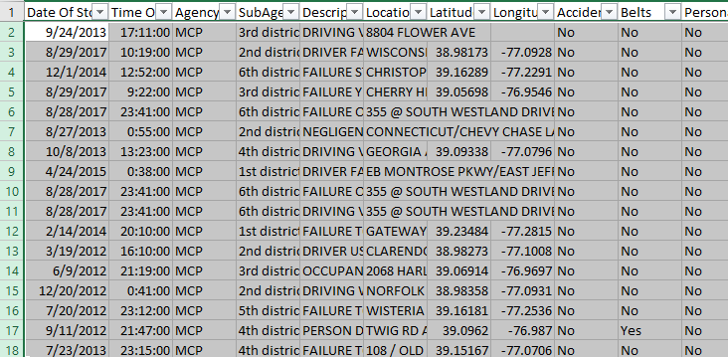

After :

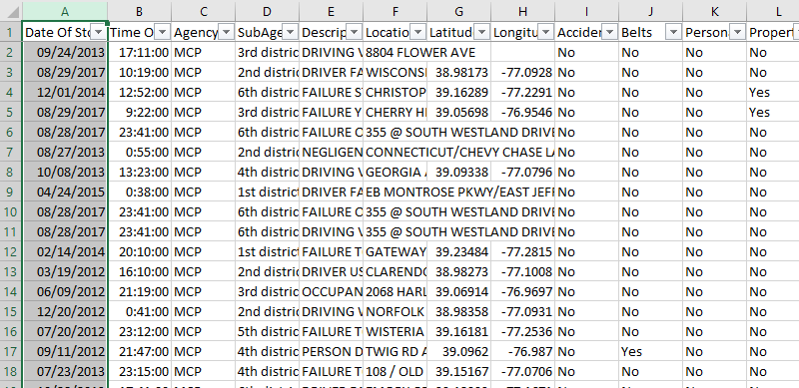

In standardization the data in unstandardized form is converted into standardize form, according to this data of traffic violation the data in date column is not is standard format thus converting the dates into standard form mm/dd/yyyy which was before mixed like m/d/yyyy or m/dd/yyyy.

2. **Standardization (Time formatting) :**

Before :



After :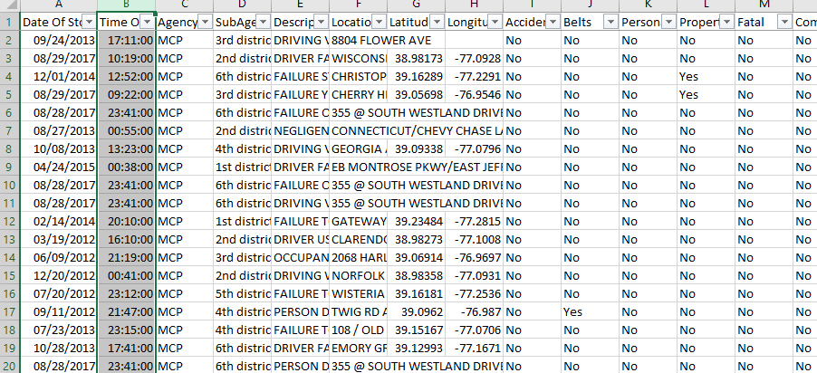

Here, standardization is done on time format which was before hh:mm:ss and h:mm:ss mixed, so this time column standardized to hh:mm:ss.

3.**Currupt data :**

Before :

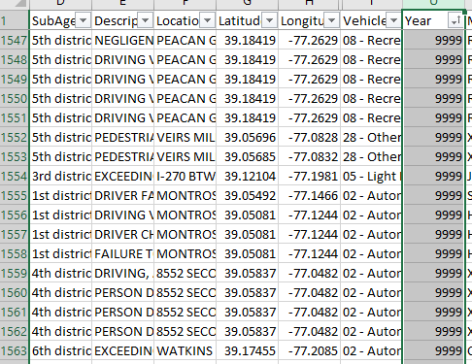

After :

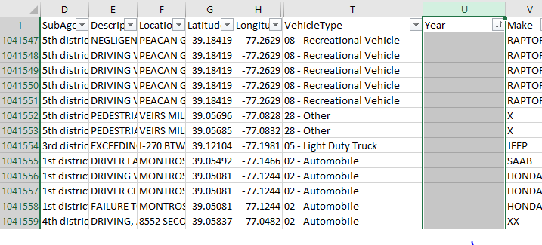

In corrupt data category of data cleaning the corrupt or irrelevant data is eliminated from the dataset, in this traffic violation dataset there were some corrupt data in vehical year column like “9999” as year which is incorrect, thus eliminated thus data from the column.

**4.Dirty data :**

Before :

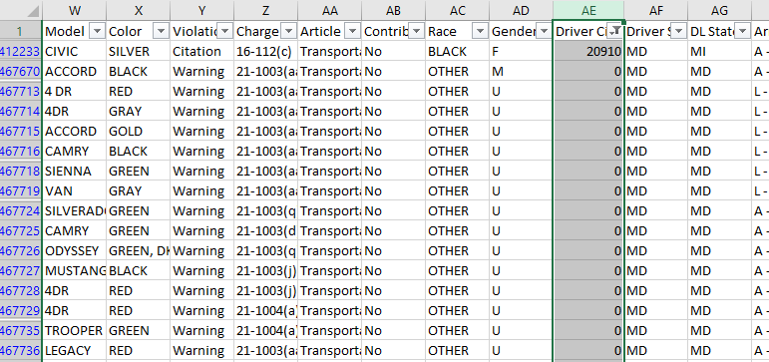

After :

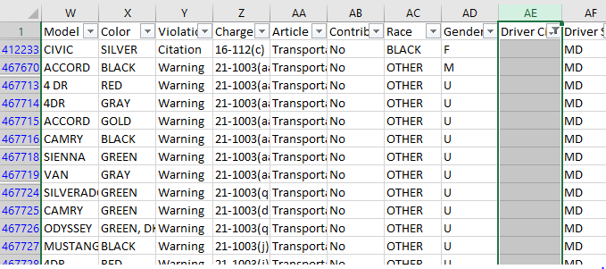

In dirty data category of data cleaning the irrelevant data or data which is dirty and of not in relation with the column data needs to be eliminated of changed, in this dataset of traffic violation the data in column named driver city contains some data which does not matches the data type such as the column needs city names but has numeric data like “0” thus it is been eliminated.

5.**Removing Special Characters From Location :**

Before :

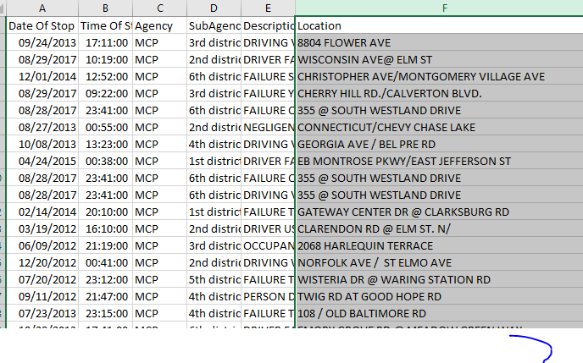

After :

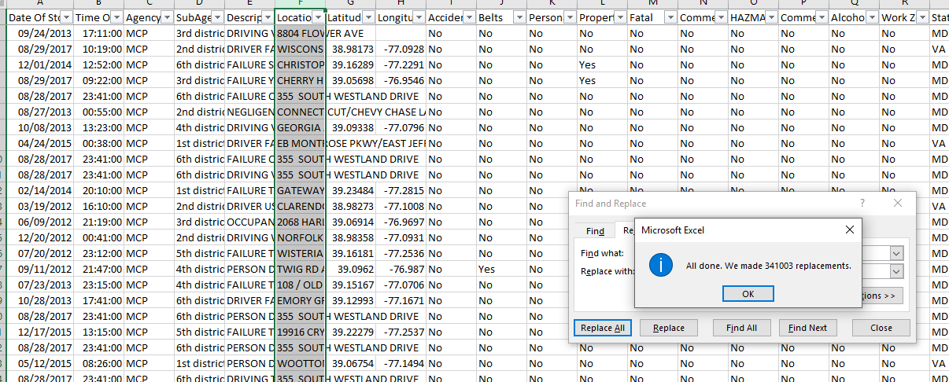

Removing special characters is the form in which the data in the column contains some values having special characters like “@” which needs to be removed to contain the consistency of data thus all special characters from location column are removed. Here I have changed 341003 places where the @ character is been removed.

1. **Data Visualization:**
2. **Finding the highest and lowest traffic violation from year 2012 to 2018 ?**

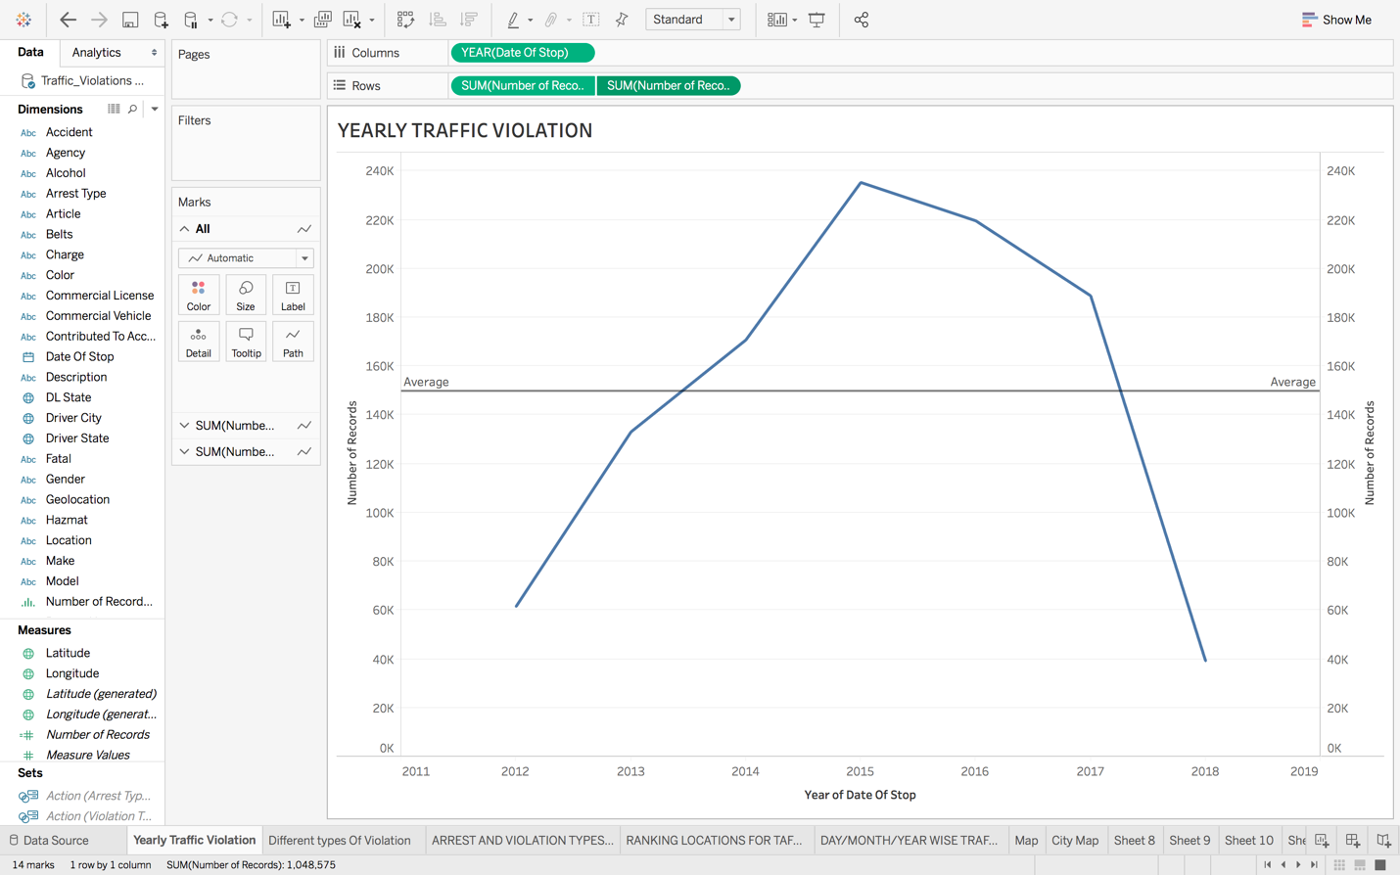

The above chart represents traffic violation in Maryland from year 2012 to year 2018, where year 2018 seems to be minimum but cannot me considered as minimum of all because it’s the present year and the data is only up to 20th Mar,2018.Thus by analyzing the graph it is clear that the minimum traffic violation was in the year 2012 which was approximately 61,531 and on the other hand the maximum was in the year 2015 which was approximately 235,349. In the above visual we have also added an average line which shows the average from total count and we can easily look at the years when the count is gone beyond the average i.e. 2014, 2015 and 2017 and also below average i.e. 2012 and 2013. Thus we can also take a rough prediction that in this present year of 2018 the violation is minimum for now and looks like will not exceed the average, which means that the traffic violations is under control for this year.

1. **Find different type of violations involved and different type of arrests done in traffic violation ?**

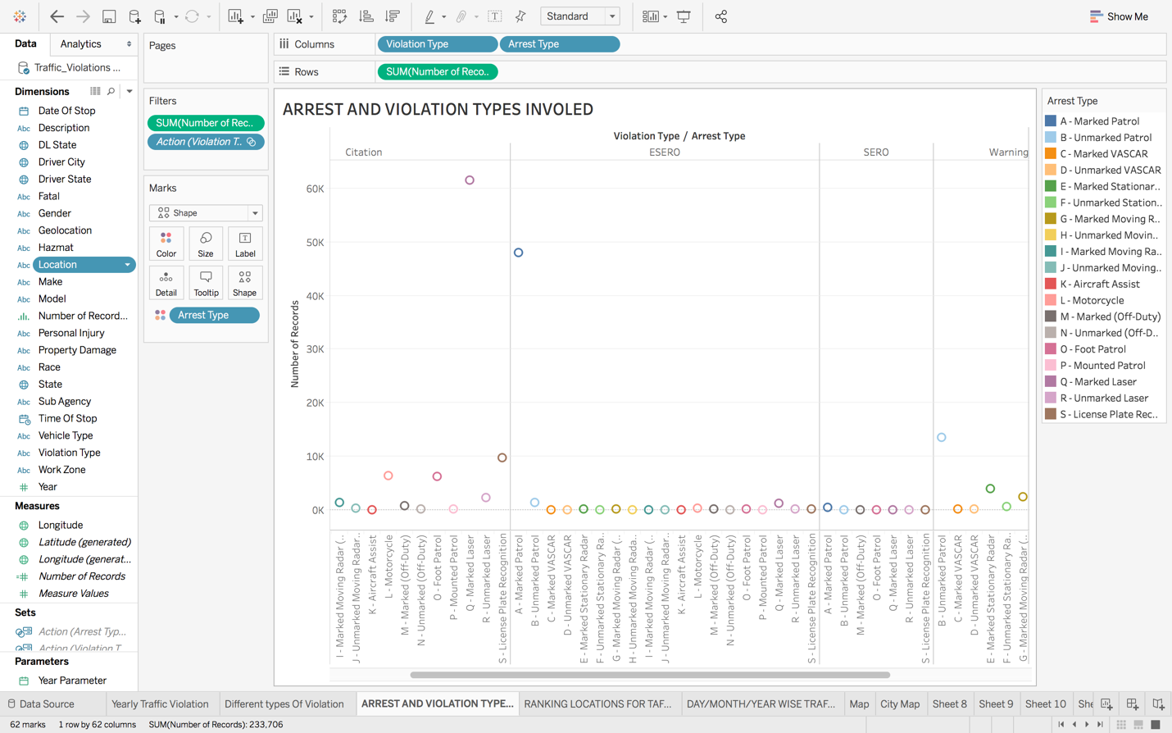

In the above visual the row represents the number of records involved in traffic violation where as columns represent the violation types and arrest types. There are 4 different types of violation i.e. Citation, Essero, Sero, Warning on the other hand there are 19 types of arrest which can de done when caught in the above 4 types of violations. The highest number of records observed for Citation type is under Q- Marked Laser violation which is 61,478 and the minimum here is under K- Aircraft Assist violation which is 18 in sum of count. Next, the highest number of records observed for Esero type is under A-Marked Petrol violation which is 47,949 and the minimum here is under P-Mounted Patrol violation which is 2 in sum of count. Next, the highest number of records observed for Sero type is under A-Marked Petrol violation which is 373 and the minimum here is under O- Foot Patrol violation and S- License Plat Recognition which is 1 in sum of count.

Next, the highest number of records observed for Warning type is under Q-Marked Laser violation which is 36,467 and the minimum here is under K – Aircraft Assist violation which is 24 in sum of count. From all the above reading we come to know that the max record is under Citation and min is under Sero. Thus, the above graph is a circle view graph which gives a combination of different types of violations and arrest types.

1. **Find traffic violation records with respect to day, month, year?**

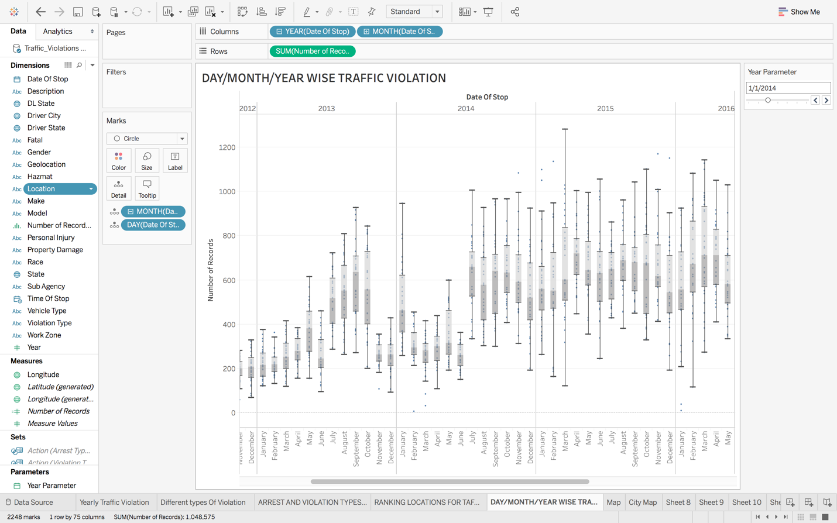

The above graph is a Box and Whisker type of graphs which shows many values like Upper Whisker, Upper Hinge, Median, Lower Hinge and Lower Whisker

1. **Finding traffic violation at different locations of Maryland with description of the violation ?**

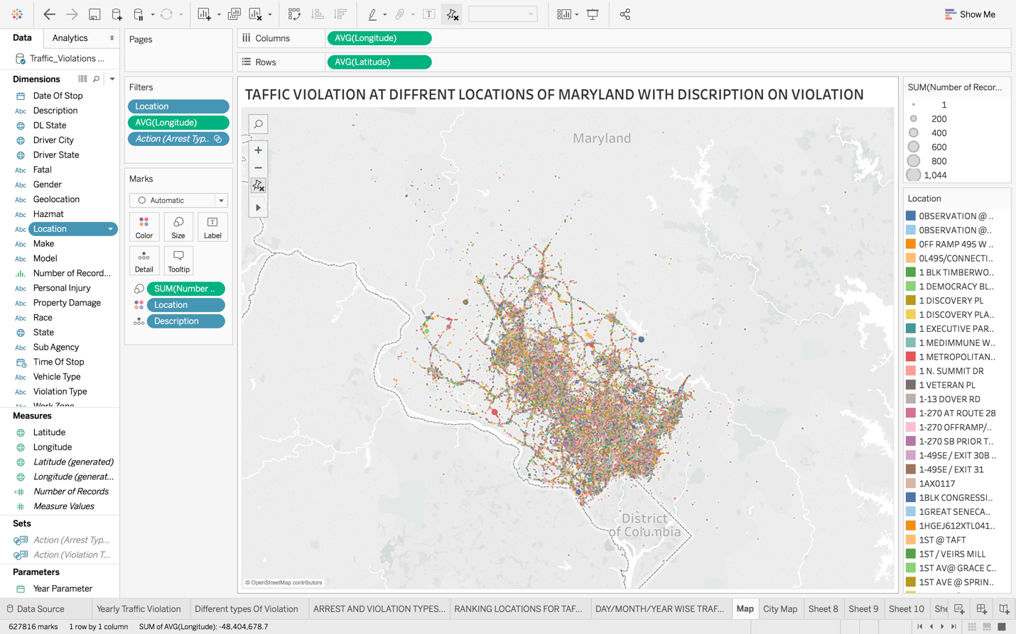

The above visual is the map showing traffic violation at different locations of Maryland with their descriptions of violation. At the extreme right of the screen shows the size and shape representation of the sum of number of records and also locations represented by different colors. The maximum traffic violation can be located at 10901 West Lake Drive for Exceeding Maximum Spped Limit 39MPH in a posted 30MPH Zone, latitude 39.0, longitude -77.1 and recorded violence is 1044. On the other hand the minimum records of traffic violation is 1 which is a many places.

1. **Finding the city with highest traffic violation in Maryland?**

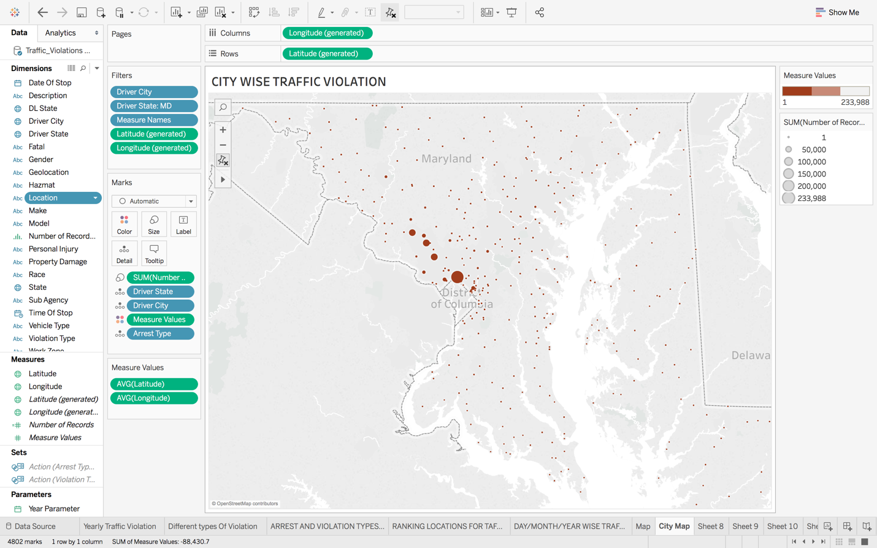

The above graph is called symbol map in tableau which is been used here to find out the city in which maximum traffic violation is done. The violation records range from 1 to max 233,988 which is represented in the map using 3 different shades of color which vary according to the density of the violence in a particular city and also the size of the circle increases with the increase in the count of records and reduces, if the records decrease. In the above map the maximum sum count recorded is at Silver Spring City which is 233,988 and the minimum is recorded at Marriotts Ville, West Minister and many more which is 1.

1. **Finding causes and outcomes of traffic violation?**

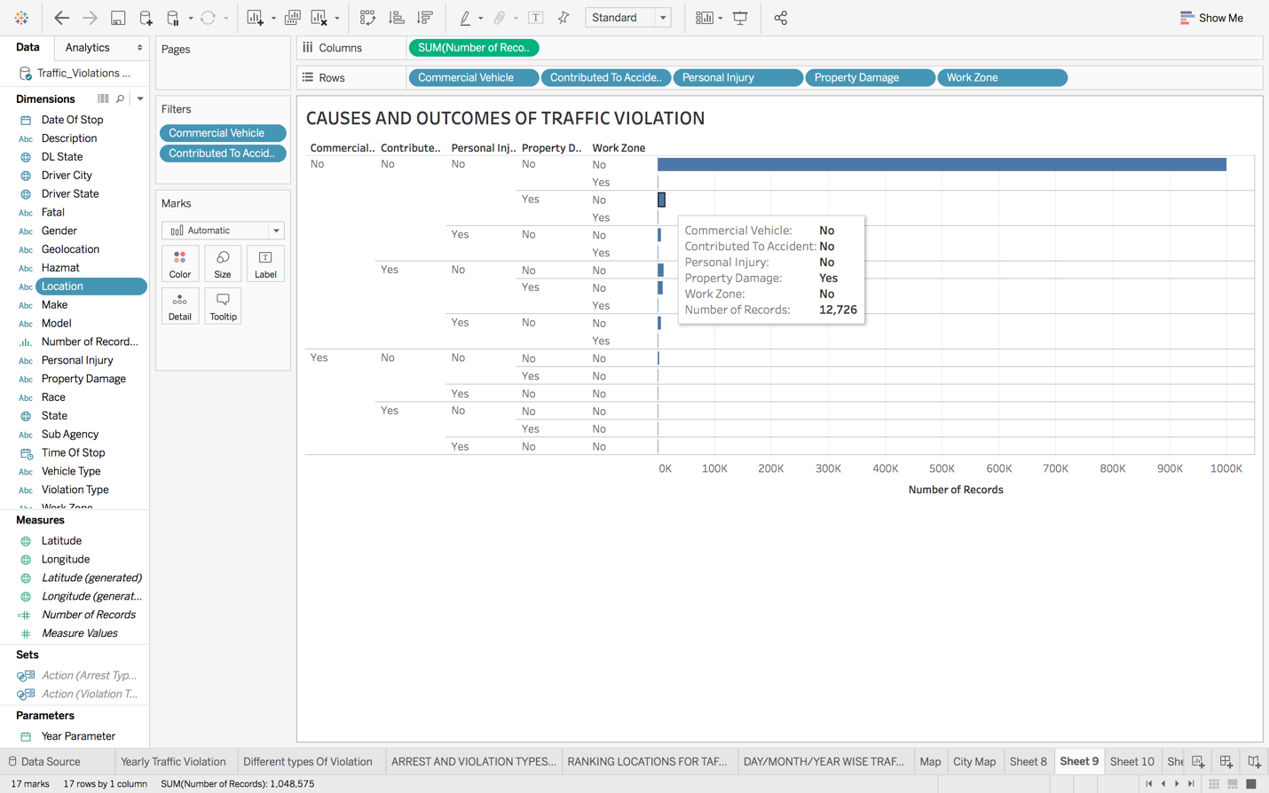

In graph represents many causes and outcomes of traffic violations like work zone and commercial vehicle can be considered as causes and accident, personal injury, property damage is considered under outcomes of the causes. As we can see that the maximum record does not have any contribution in the causes and outcomes we mentioned i.e. the violations recorded do not come under commercial vehicle, do not contribute to accident, personal injury, property damage, work zone which means that there are some other factors of violation under which the maximum violation is recorded. Whereas there are few records in which one or more of the factors in the graph are considered for example if we look for the third row it say that the violation was not due to commercial vehicle, not contributed to accident, no personal injury, but there was some property damage due to the violation and nor it was a work zone, and thus considering the yes and no for third row there are in total 12,726 records.

1. **Find the time range in which traffic violation is the minimum?**

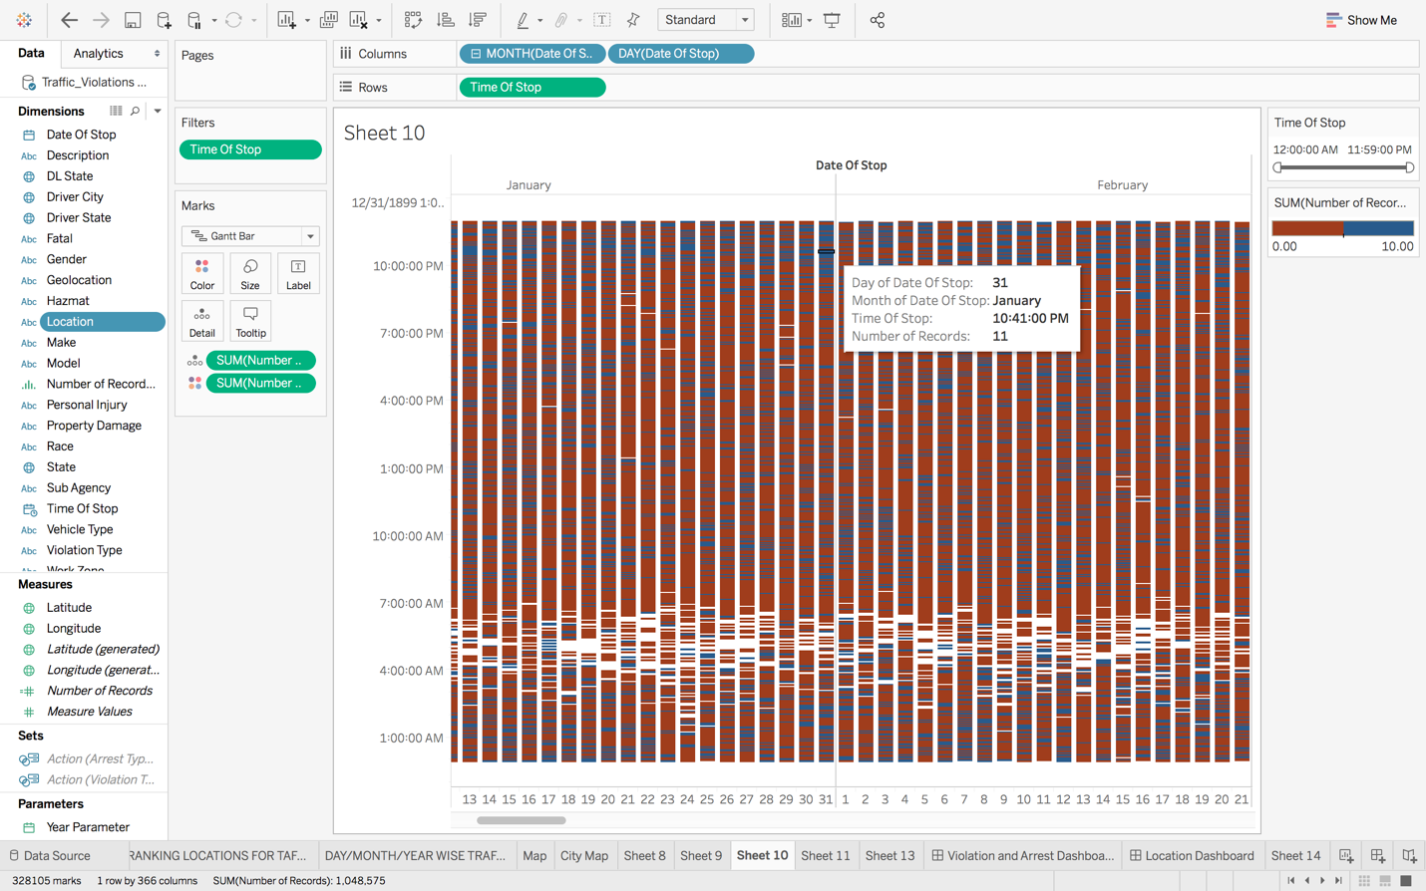

The above graph represents the number of violations with respect to time range with each day and month, here we have taken a time range of 3 hour interval and we have also added some color range for number of records i.e. sum of records which are less then 5 shows red color whereas the records which are more then 5 shows blue color and the time when the is no record of violation is blank which space. Thus our purpose was to find the time range where minimum violations are recorded and that is from 2 am to 7 am and after this time range the violation gradually increases as we move towards pm. Also one more interesting reading are found that 25th and 26th December have the lowest violation recorded in all time ranges.

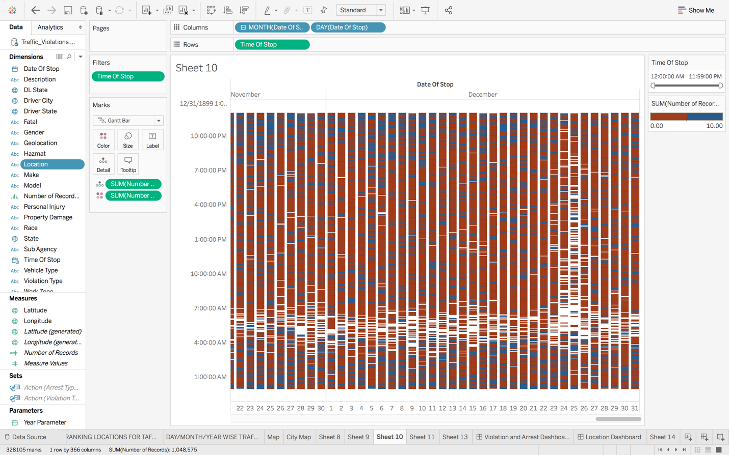

1. **Finding the time range in which traffic violation is minimum and maximum with respect to months in combination of years from 2012 to 2018.**

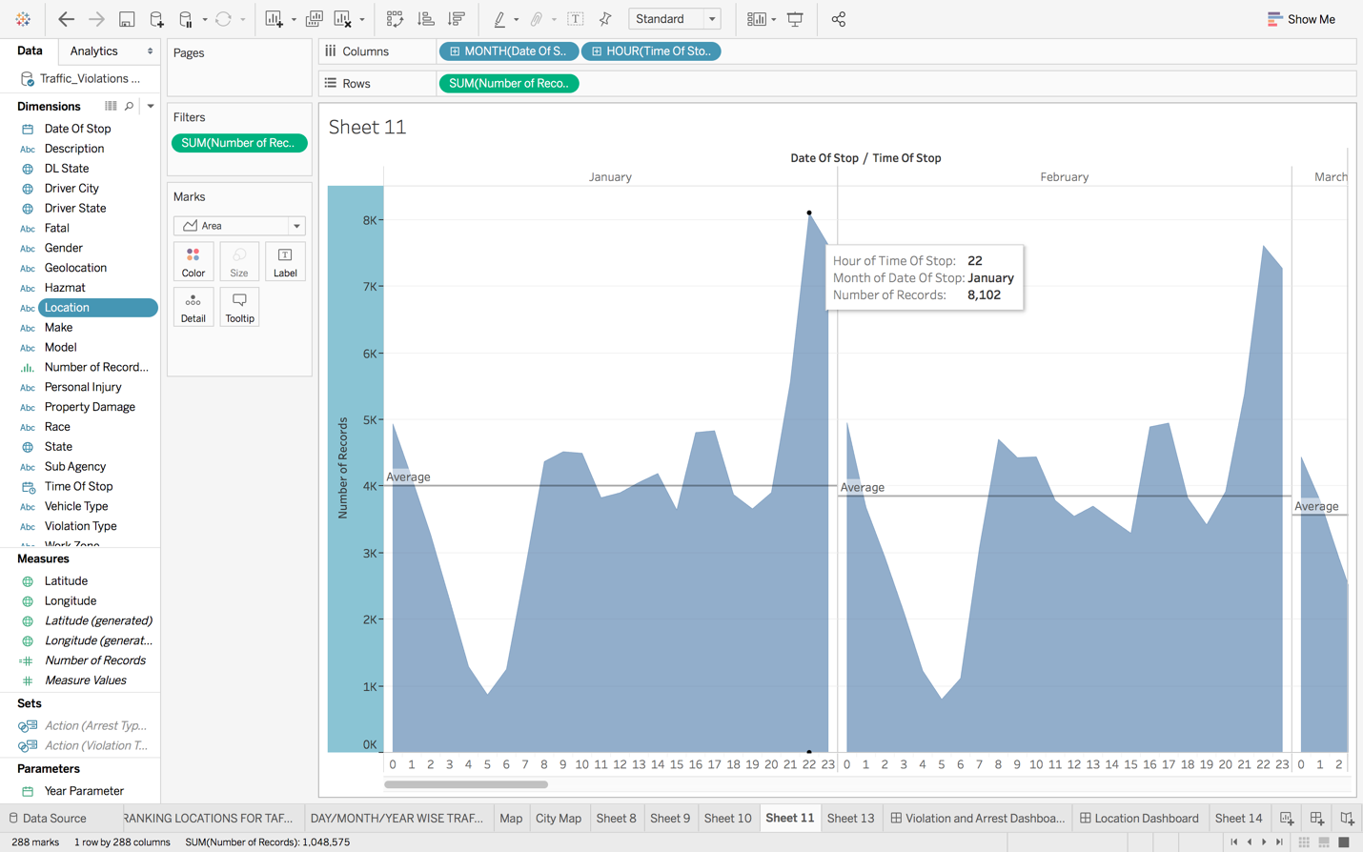

The above graph represents the hour of stop due to violation plus the month of stop and number of records which combines all the years from 2012 to 2018. According to the reading the traffic violation is above average at 1 am and gradually decreases until 5 am, after 5am the graph again starts increasing and goes beyond average at 8am and then till 8pm there is continuous increase and decrease in the graph but near to the average and then a fast increase is see at 22 hours i.e. 10pm. Thus, most probably all the months have almost same reading but with minimum changes. Thus we can predict that control on traffic violation is required more during day time and evening times whereas during early morning control measures are not that mandatory.

1. **Dashboard:**

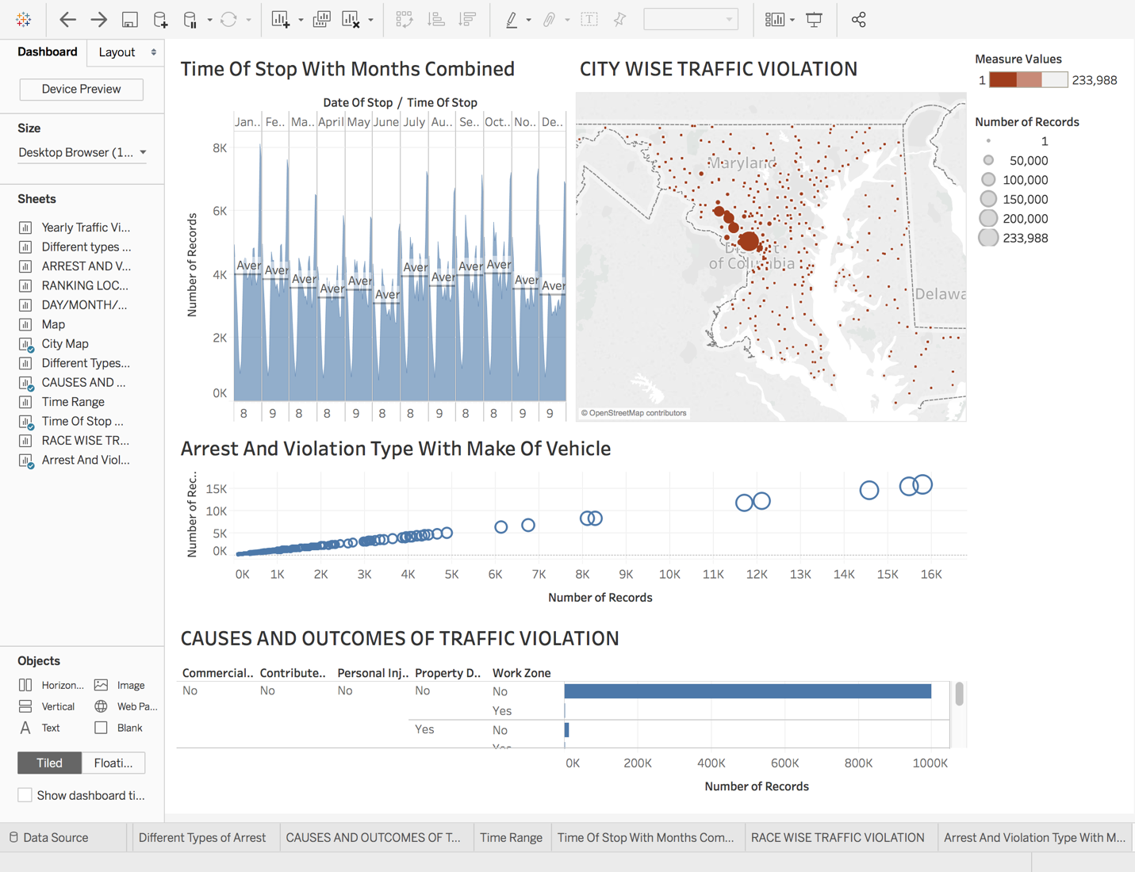

The dashboard above shows four different and major elements of the project such as the time factor analysis of violation, city wise traffic violation in the state of Maryland, different types of violations causes, and their different types of arrests done with respect to the make of the vehicle involved in violation and the final element representing some causes of traffic violations and the outcomes of those violations. Thus summarizing the key points of the project with the use of dashboard.

1. **Story – Telling :**

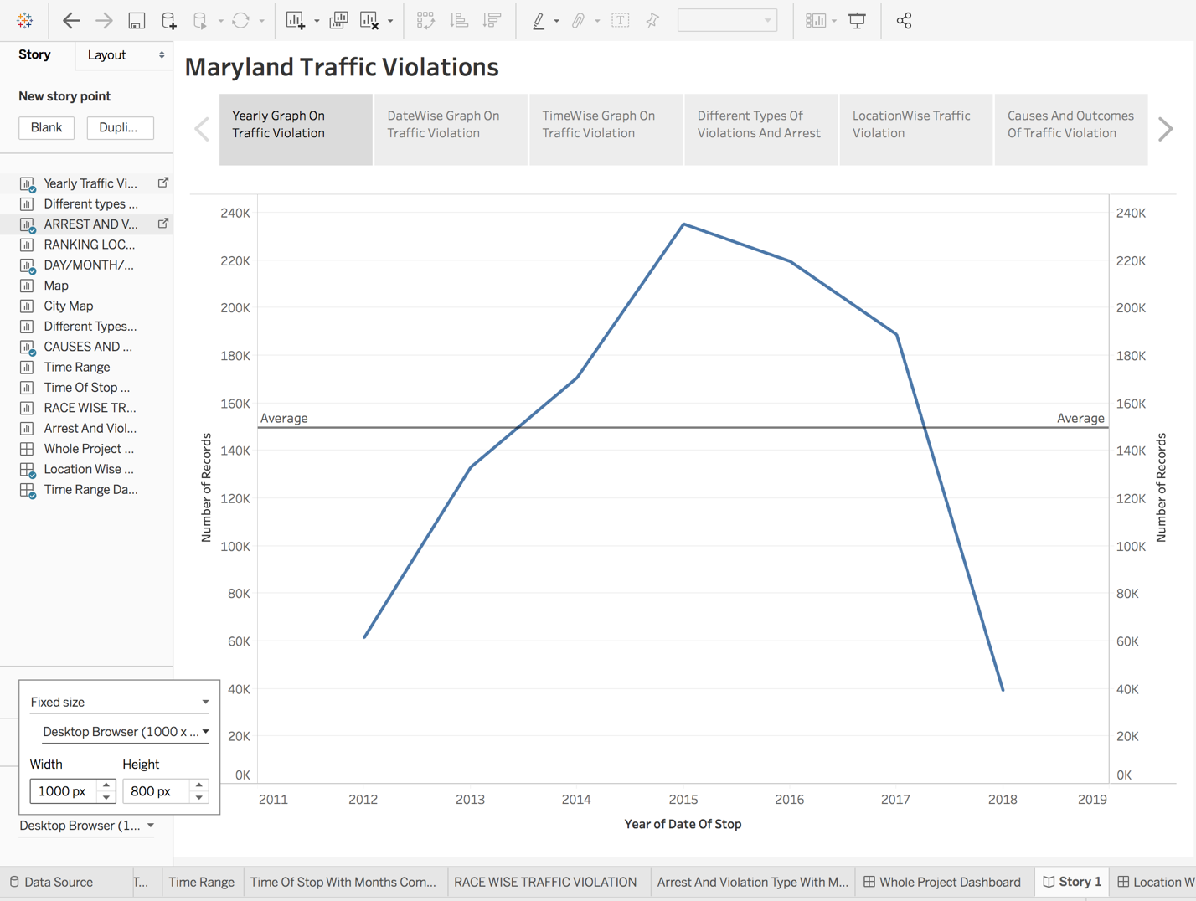

This story is about traffic violation in Maryland city from the year 2012 to 2018 and to introduce I start which this graph presenting sum count of traffic violation from 2012 to 2018, as we see that the violation was minimum in year 2012 then started raising till 2015 and the most interesting thing is that after 2015 violence awareness increased and again the graph started falling down and is expected to be below average line in the present and coming years.

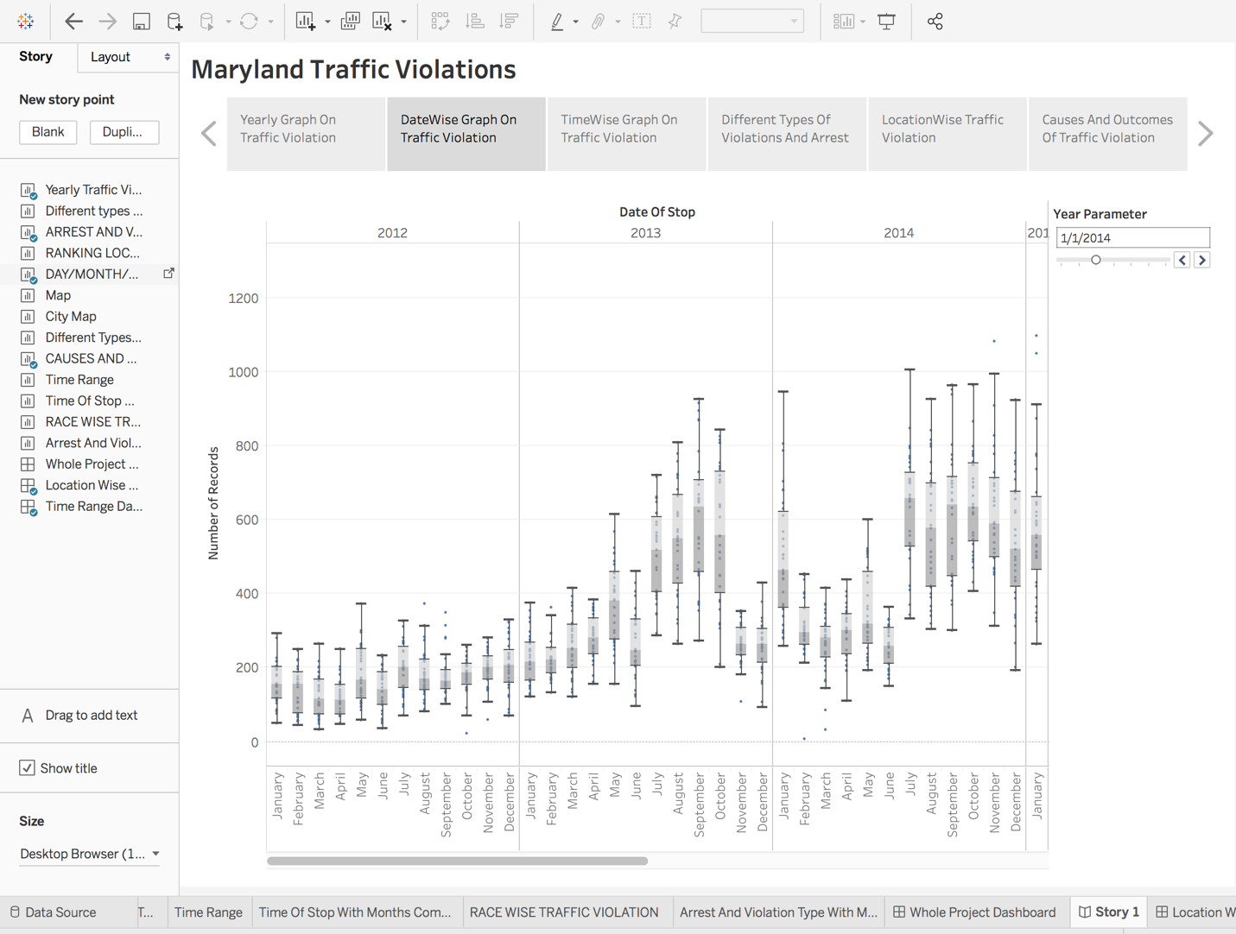

In ahead we take a step deeper in our story where the second graph tells about the classification of traffic violation data with respect to day month and year so that we can analyze the increase and decrease in the violation with respect to day month and year which will help in increasing or decreasing in the security and public safety in future if the violation shows constant for a particular or specific day(may be charismas day when violation is not too much so the security can be decreased and visa a versa on some other day ), or a specific month when security and public safety varies on the reading of previous months of last 3 years may be.

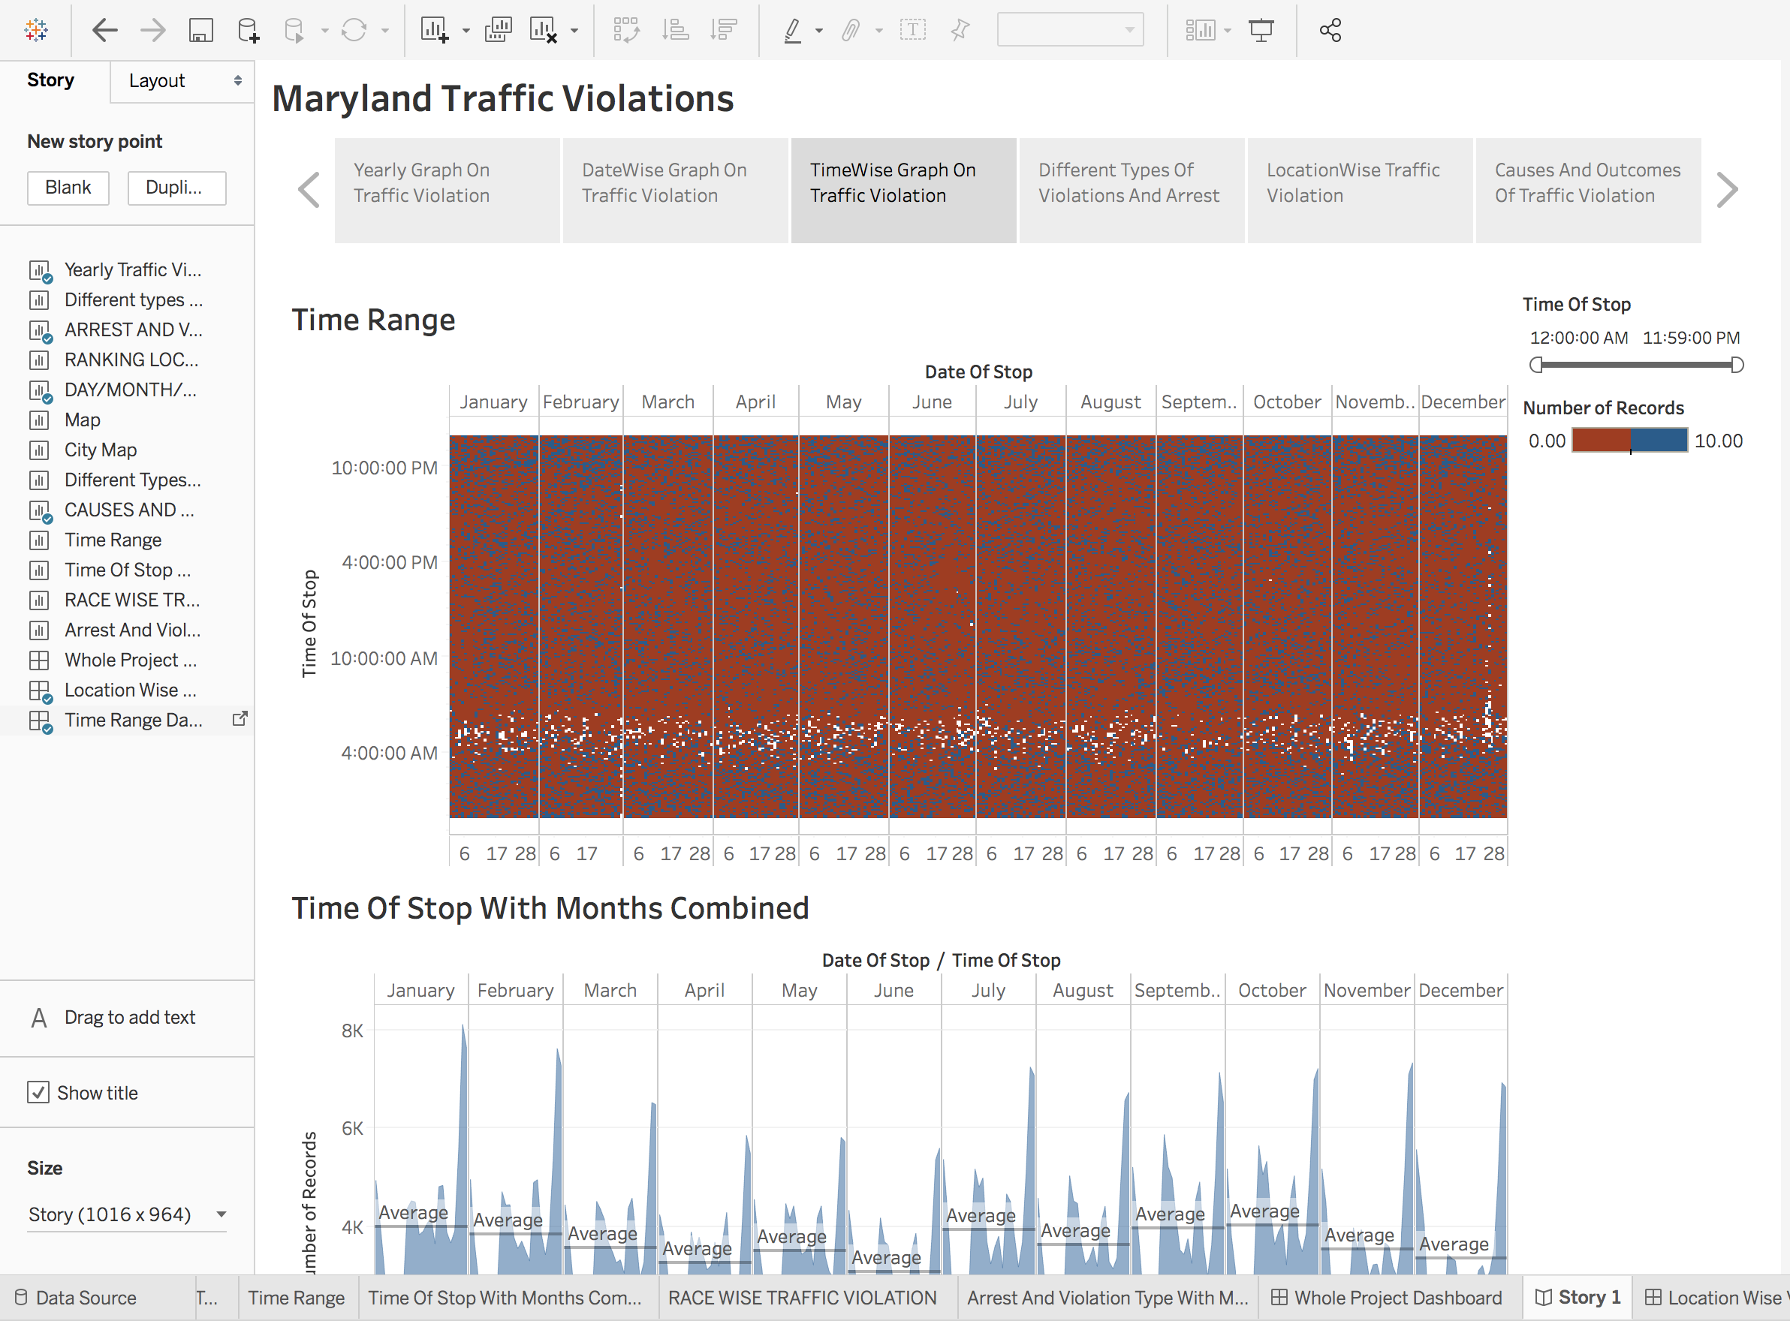

As we move ahead we go in more detailed study of traffic violation in Maryland which is time based in the first graph, the reading will be done according to the time range to find out record of violation in each range of time for all specific days, months and years from 2012 to 2018. The most interesting finding in this visual is that the traffic violation is minimum in the time range from 4am to 7 am and it increases eventually from 10 am till mid night and time range from 10 pm onwards is found to be most active violation time, which could be predicted for many reasons such as stress level, work load, frustration, traffic conditions and much more because it’s the time when people outburst from the work and try release their stress and also that’s the time when some people are in party mode and unwantedly get into violation, thus analyzing this kind of data which is presented in time range helps, understand the reasons of violation and helps in increasing awareness and safety.

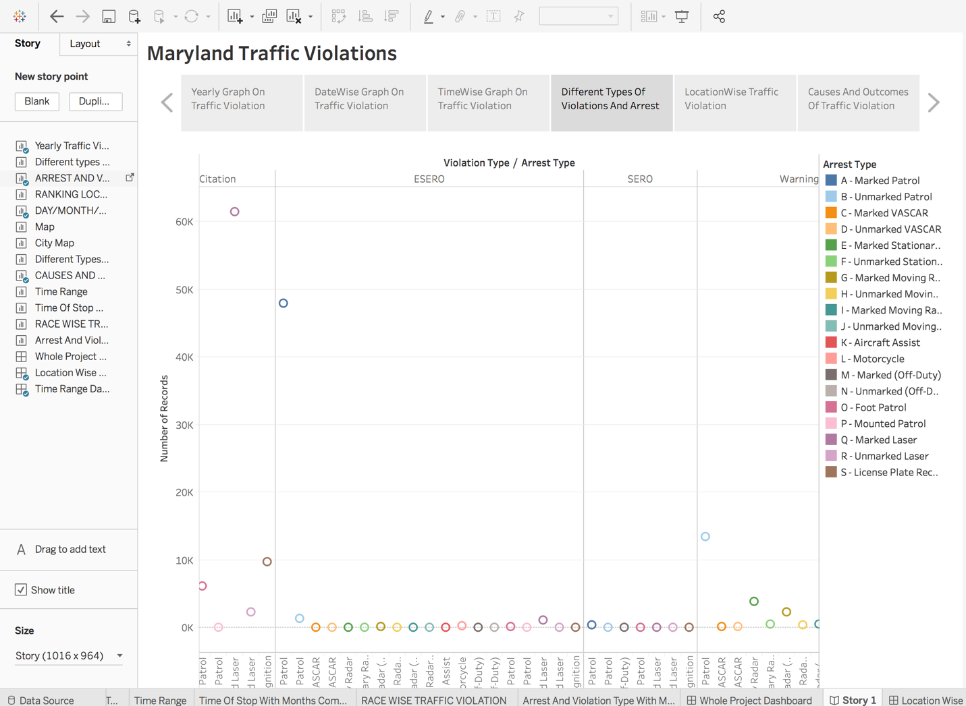

As we move forward in our store we now shift onto a different sight which represents the different types of violations and different types of arrests caused due to these different violation type. Here in this visual we mainly look at the minimum and maximum readings from the combination of violation type and arrest types. As the result of these reading we found that the highest combination of arrest and violation types together is of Citation as violation type and Q- Marked Laser as arrest types. On the other side the minimum combination is shown by SERO as violation type and License plate recognition as arrest type. Thus using this visual we can find many more combinations of violations and arrest and people can improve on their way of driving.

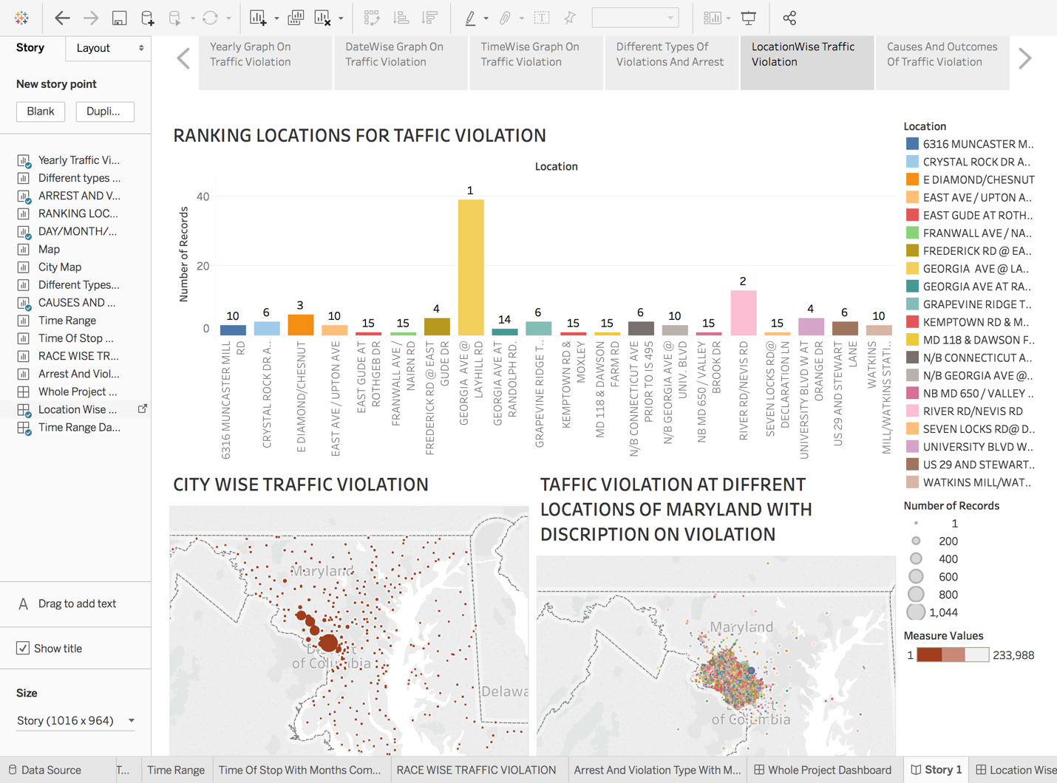

As we have now understood about the different types of violation and arrest we now look at the locations at which traffic violations took place the first graph represents the ranking of traffic violations of the top 20 locations where as the second graph represents the city wise traffic violations where the more count shows bigger circle and as the count reduces the size of the circle representing city also reduces respectively. The third graph represents the exact latitude and longitude where the violation took place. These all representation of the locations of traffic violation helps in controlling the violation and is useful in public safety too.

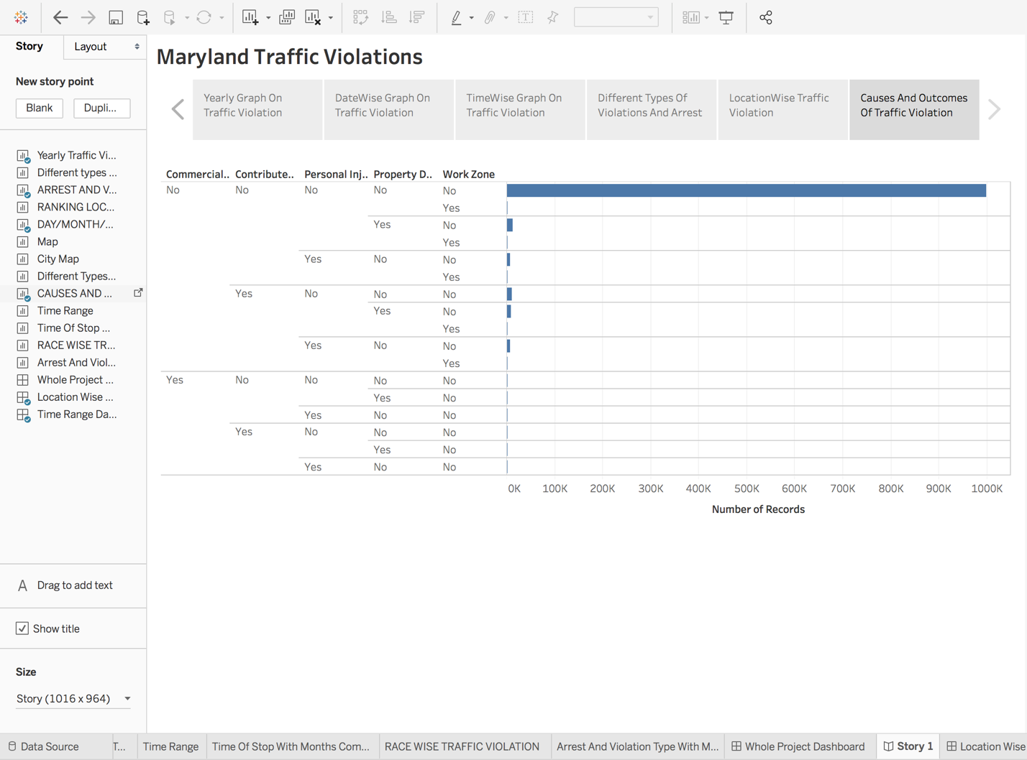

Thus, to conclude this last visual shows the causes and outcomes of traffic violation where the causes according to the dataset can be commercial vehicle and work zone while the outcomes are accidents, personal injury and property damage. Thus, this final graphs help to conclude that traffic violation as a serious offence and people needs to know about is outcomes and become aware towards the society to prevent violation and help people to be safe and happy.